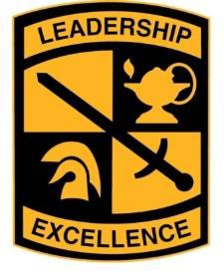
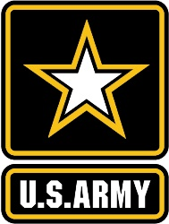
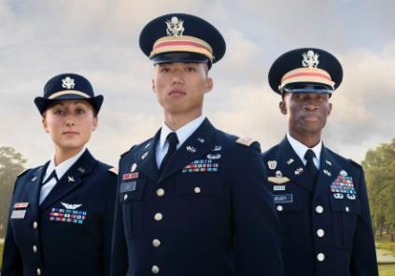

Army ROTC Illinois State Tuition Waiver (ISTW) Scholarships

Are you interested in learning about Army ROTC and competing
for free tuition at one of the below State Schools?

Eastern Illinois University, Illinois State University, Northern Illinois University,
Northeastern Illinois University, Southern Illinois University Carbondale
Southern Illinois University-Edwardsville, University of Illinois at Chicago,
University of Illinois at Urbana-Champaign, Western Illinois University

If you are interested in pursuing a future as a Commissioned Officer in the United States Army through the ROTC program while earning your degree at one of the schools listed above, you may be eligible for and receive the Illinois State Tuition Waiver (Scholarship) by participating in this year’s ISTW Combine.

To be eligible you must:
- Receive a 20 (ACT) / 1000 (SAT) or higher on the ACT/SAT Exam
- Have a high school GPA of 3.0 or higher
- Pass the Physical Fitness Test given at the ISTW Combine which includes a:
  - 1-mile run
  - 1 minute of push-ups
  - 1 minute of modified sit-ups (hands on opposite shoulders)
- Interview at the ISTW Combine with one of the Army ROTC Instructors
- Gain acceptance into one of the universities listed above. The applicant must be a resident of the State of Illinois to earn this tuition waiver.

The date, time and location of the fitness test and interview is as follows:

- OCTOBER 23, 2021, 9:00 am - 1:30 pm at Camp Lincoln at Camp Lincoln Rd, Springfield, IL

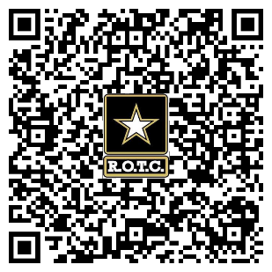
If interested in the event, please obtain an application for this event from your high school guidance counselor. Please email or mail the completed application to the point of contact below, or use the QR code to register online:
ATTN: UIUC Army ROTC Department
505 E Armory Ave, RM 113
Champaign, IL 61820
Email: arotc@illinois.edu
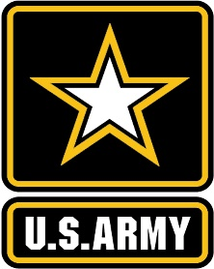
Tuition Waiver Scholarship Application DUE: 16 OCT 2021
(Please Print or Type)

Full Name: Date:

High School:

ACT or SAT Score: ____
GPA:

- mail: ___________________________
Phone #:

Local Address: _________________________________________________________

______________________________________________________________________

The date, time and location of the fitness test and interview are as follows:

  - Time: October 23, 2021 from 9:00 am - 1:30 pm
  - Location: Camp Lincoln, 1301 North MacArthur Blvd, Springfield, IL 62702

You are responsible to provide your own transportation to and from event.

Please list the schools of interest and number in priority (1, 2 or 3) if applying to more than one.

_______Eastern Illinois University
_______Illinois State University
_______Northern Illinois University
_______Northeastern Illinois University
_______Southern Illinois University - Carbondale
_______Southern Illinois University – Edwardsville
_______University of Illinois - Chicago
_______University of Illinois-Urbana Champaign
_______Western Illinois University

Please submit this application by 16 OCT 2021 to UIUC Army ROTC.
Email: arotc@illinois.edu
Office: (217) 244-1407 USPS: UIUC Army ROTC (Attn: Mr. Ashworth)
505 E Armory Ave, Rm 113
Champaign, IL 61820

